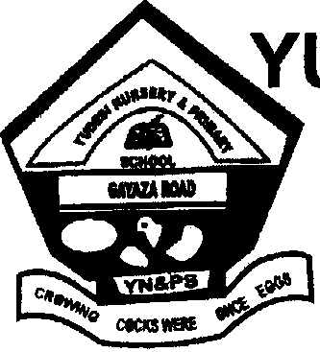
YUDESI DAY & BOARDING PRIMARY SCHOOL
GAYAZA ROAD CAMPUS ACADEMIC BOARD
PRE-P.L.E EXAMINATIONS SET 1, TERM 3, 2017
CLASS : P. 7
SUBJECT : MATHEMATICS
DURATION : 2 HOURS 30 MINUTES

Index No.
Candidates Name: ______________________________________
Candidates’ Signature: ______________________________________
District Name: ______________________________________
Read the following instructions carefully.

FOR EXAMINERS USE ONLY
QN. NO. | MARK | SIGN
1 - 10
11 - 20
21 - 22
23 – 24
25 – 26
27 – 28
29 – 30
31 – 32
TOTAL

1. This paper has two Sections: A and B
2. Section A has 20 answer questions
40 marks)
3. Section B has 12 questions (60 marks)
4. Answer ALL questions. Answers to both
sections must be written in the spaces
provided.
5. All answers must be written using a blue
or black ballpoint pen or ink Diagrams
should be drawn in pencil.
6. Unnecessary alteration of
work may lead to loss of marks.
7. Any handwriting that cannot be
easily read may lead to loss of marks.
8. Do not fill anything in the box
indicated for examiner’s use only.

SECTION A (40 MARKS);
1. Workout; 14 + 53

______________________________________________________________
2. Write 99,040 in words.

______________________________________________________________
1
6
3
4
x
3. Multiply;

______________________________________________________________
4. Simplify; 5ab – 2xy – ab + 7xy

______________________________________________________________
5. Find the next number in the sequence; 49, 47, 44, 39, _____

______________________________________________________________
6. A man bought a shirt at shs.55000 and he sold it at a loss of shs.15000. How much did he sell the shirt?

______________________________________________________________
1
8
7. Express kg as grams.

______________________________________________________________
8. Workout; ⁻3 – –9

______________________________________________________________
9. Find the value of k in degrees in the diagram.
120⁰

4k

______________________________________________________________
10. What is the place value of the underlined digit in the number 54089.

______________________________________________________________
11. The meeting which took 45 minutes, started at a quarter past 11 0’clock.
At what time did it end?

______________________________________________________________
12. What is the additive inverse of ⁻4 ?

______________________________________________________________
13. The graph below shows the number of phones sold in a shop.

12
10
No. of phones
8
6
4
2
0
MON TUE WED THUR FRI SAT SUN
Days of week
How many phones were sold altogether?

______________________________________________________________
14. Solve; 2y – 1 ≤ 3

______________________________________________________________
15. Given that set M = {a, b, c, d, e} N = {a, e, i, o, u}, find (N – M)

______________________________________________________________
16. Express 16:50p.m in 24 hrs.

______________________________________________________________
17. Find the simple interest of shs.24,000 at a rate of 4½% per month for 3 months.

______________________________________________________________
18. A ox of mangoes weighs 20.25kg. The empty ox weighs 2.25kg. If each mango weighs 30 grammes, how many mangoes are in the box?

______________________________________________________________
19 Write 145 in Roman numerals.

______________________________________________________________
20. Find the area of the shaded part if the valume of the figure is 100cm³.

4cm

5cm

______________________________________________________________
SECTION B;
21. Given that n(A) = 20, n(B) = r, n(A∩B) = 12 and n(AᴜB) = 31.
a) Complete the venn diagram below. (3marks)

n(A)= n(B)=

______________________________________________________________
b) Find the number of members in set B only. (2marks)

______________________________________________________________
22a) Solve; (k – 2) = (5k – 2) (3marks)

______________________________________________________________

b) Solve; 2y – 3 (1 – y) = 7 (2marks)

______________________________________________________________
23. At a party of the guests were females and the rest were males if ¼ of the males were children and 60 more females than males attended.
5
7
a) Find the fraction of children. (3marks)

______________________________________________________________
b) How many guests attended the party? (2marks)

______________________________________________________________
24. The table below shows a programme for a staff meeting held in a school.
Time | Programme | Presenter
11:15a.m – 11:20 | Opening prayer | SEC
12:00 – 12:40p.m | Communication from chair | H/T
12:40p.m – 2:40p.m | Reading of previous minutes | SEC
12:40p.m – 3:15 | Reactions | STAFF
3:15p.m – 3:20pm | Closure | D.O.S
a) How long was the meeting? (2marks)

______________________________________________________________
b) Express the time the staff meeting ended in 24 hour clock. (2marks)

______________________________________________________________
c) If the timekeeper was giving updates after every 30 minutes, how many updates did the timekeeper give? (2marks)

______________________________________________________________
22
7
25a) Workout the perimeter of the shaded part take π = (3marks)
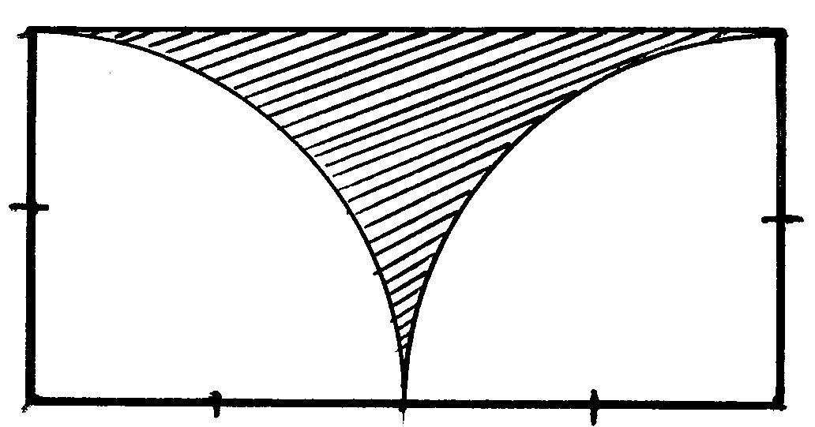
E
A
B
D

7cm

C

______________________________________________________________
22
7
b) Find the area of the shaded part use π = (2marks)

______________________________________________________________
26a) A water tank has a diameter of 230cm and height of 2m, find the capacity of the tank in litres. (3marks)
______________________________________________________________
b) Express 0.154 litres in millilitres. (2marks)

______________________________________________________________
27a) In a club, the weight of members is as follows;
6kg, (2p – 6)kg, 76kg and 2pkg. If the average weight is 63kg, find the value of p.
(3marks)

______________________________________________________________
b) Find the median weight. (2marks)

______________________________________________________________
28. A parent bought the following items for his son;
- 3 dozens of books at shs.500 per book
- 2 pens at shs.450 per pen
- 3 pencils at shs.30 per pencil
- 5 rulers at shs.2000
Find the total amount of money the parent went with if she was given change of shs.1500. (5marks)

______________________________________________________________
29. Using a ruler, a pair of compasses and a pencil, only construct a parallelogram ABCD in which BC = 7cm and BCD = 135⁰ and line AB = 5cm. (4marks)

______________________________________________________________
30. A regular polygon has its interior angle as 135⁰.
a) How many sides has the polygon? (3marks)

______________________________________________________________
b) Find the interior angle sum of the polygon. (2marks)

______________________________________________________________
31a) Workout; 1.2 x 0.15 (2marks)
2.4 – 0.9

______________________________________________________________

b) If r = , p = and s = Find the value of rp + s (2marks)
2
3
1
2
1
4

______________________________________________________________
32. The graph below shows the cost of sugar and posho at maama Mambo super market.

Cost in shillings
2
8000

sugar

6000

4000

posho

2000

0 1 2 3 4 5
No. in kg

a) How much does each kg f posh? (2marks)

______________________________________________________________
b) How many kg of sugar can I buy with 7000/=? (2marks)

______________________________________________________________
c) Find the cost of 3kg of posho and 1½ kg of sugar. (2marks)

______________________________________________________________
End!

